Loan Approval Prediction Machine Learning

Shaurya Khanna (502104123)

Ajay Wadhwa (502104008)

Introduction (MileStone 2)

In this research article, we shall discuss the Loan Approval Prediction Problem. We have to categorize whether or not the loan application will be approved, which is a classification difficulty. Predicting a class label for a specific example of input data is a classification issue. Examples of categorization problems include sentiment analysis, cancer detection, spam email detection, and others. To identify the clients who are eligible for the loan amount, a data set containing key features is used. In order to automate this process and speak directly to these clients. Using automated tools such as Auto Viz, Pandas Profiling, Dtale, and Sweetviz, we have carried out exploratory data analysis. To forecast the target variable, we will employ ensemble learning strategies and artificial neural networks. In order to evaluate which combination offers us the maximum accuracy, we will contrast the average learning results of the three-classification algorithm with those of the six-classification algorithm.

Literature Review (Milestone 2- Min 7 papers)
1)Prediction for Loan Approval using Machine Learning Algorithm
Ashwini S. Kadam, Shraddha R. Nikam, Ankita A. Aher, Gayatri V. Shelke, Amar S. Chandgude
The goal of this essay is to devise a quick, easy, and immediate procedure for choosing the qualified applicants. Information on previous clients of various banks who received loans based on a set of criteria. The machine learning model is trained on that dataset to produce trustworthy results. This model's main objective is to disburse loans safely. This classification problem is forecasted using the SVM and Nave Bayes algorithm.
The dataset contains the following features: 1. Application Id 2. Gender 3. Marital Status 4. Dependents 5. Your educational background; 6. Your employment situation; 7. Income Income of Co-Applicant 8 Loan Amount 9 Credit Profile 10. Loan Status.
The Naive Bayes model was found to be more accurate and efficient than other models. It also functions correctly and meets all specifications set forth by clients or lenders. This model accurately and exactly estimates the result. Based on the customer's credit quality, it properly forecasts whether a loan application will be granted or rejected.
2)Loan Approval Predictions based on ML Approach
Kumar Arun, Garg Ishan, Kaur Sanmeet (sh.arun.rana@gmail.com, ishangarg9292@gmail.com, sanmeetkbhatia@gmail.com )
The main objective of this essay is to predict whether or not giving a loan to a particular person will be risky or safe. There are four sections in this article, which are as follows. 1) Data gathering 2) Comparison of machine learning models using the gathered data 3) Training the system with the most promising model 4) Evaluation of the machine learning algorithm.
Six machine learning classification models have been applied to forecast Android applications. The open source R programme was employed. The models are as follows: - 2.2.1 Adaboost (ADB); 2.2.2 Random Forest (RF); 2.2.3 Support Vector Machine (SVM); 2.2.4 Linear Models; 2.2.5 Neural Network; 2.2.6 Decision Trees; 2.2.7 Random Forest (RF).
The conclusion was presented after. These ML models met all Banker requirements and were operationally sound. This element is straightforward and may also be plugged into other systems.
3)Prediction of Modernized Loan Approval System Based on Machine Learning Approach
Vishal Singh vishalsingh220799@gmail.com, Ayushman Yadav ayushman.up10@gmail.com ,Rajat Awasthi awasthirudra3333@gmail.com .
This article's main goal is to demonstrate how machine learning models trained on previous data can be used to forecast whether or not a fresh loan application will be accepted.
For the purpose of determining how accurately the data set predicts, three machine learning techniques are used in this study. XGBoost, Random Forest (b), and Decision Tree (a) (c). This analysis can tell whether or not a potential borrower would repay a loan and whether or not their creditworthiness is sufficient. The most important factors in establishing loan eligibility are age, income, loan term, and loan amount (whether the client would be credit worthy or not). The two most important factors in determining the loan applicant's category are zip code and credit history.
4)Tree-Based Methods for Loan Approval
Mohamed Alaradi mohamed.alaradi@aspentech.com, Sawsan Hilal shilal@uob.edu.bh
In this work, a variety of statistical learning classification techniques were employed to forecast a bank's loan approval status. The main methods employed were boosting, decision trees, and other types of random forests. The decision tree approach was unsuccessful in establishing a complete and meaningful relationship between the attributes and the loan status because the apparent real function for deciding loan status is too complex to be expressed in a single decision tree. However, the failure that occurred was not due to a basic assumption of the strategy being broken. As a result, many tree techniques proved to be the most representative research methodologies. This included random forests, bagging, and boosting.
These strategies are helpful for modelling this kind of data since they represent many decision trees and compute the common vote in the end. The three strategies were graded in the same order of varying importance for credit history, income, loan amount, geography, marital status, and education, from highest to lowest. With accuracy, specificity, sensitivity, and AUC ratings of 97%, 100%, 92.5%, and 98.75%, respectively, boosting surpassed the used multiple tree techniques in terms of the selection criteria.

5)LOAN APPROVAL PREDICTION BASED ON MACHINE LEARNING APPROACH J. Tejaswini1 ,T. Mohana Kavya2 , R. Devi Naga Ramya3 , P. Sai Triveni4 Venkata Rao Maddumala
The loan approval process is essential for financial institutions. Due to a number of problems, the banking industry is continuously in need of a more precise predictive modelling system. The banking industry has a difficult time predicting credit defaulters. The system decided whether to accept or reject the loan applications.
In order to predict whether or not consumers would be authorised for loans, this study employs three machine learning techniques: Logistic Regression (LR), Decision Tree (DT), and Random Forest (RF). The experimental results show that the Decision Tree machine learning algorithm outperforms Logistic Regression and Random Forest algorithms in terms of accuracy.

As a result, in the near future, the so-called software may be designed to be more secure, dependable, and dynamic weight adjustment. This prediction module can soon be integrated with the automated processing system module. Future software can be created such that new testing data should also participate in training data after a given period of time. Currently, the system is trained on an old training dataset.

6)V. Singh, A. Yadav, R. Awasthi and G. N. Partheeban, "Prediction of Modernized Loan Approval System Based on Machine Learning Approach," 2021 International Conference on Intelligent Technologies

The most crucial task for the banking sector is loan recovery. The process of improvement is crucial in the banking industry. Utilizing several categorization techniques, a machine learning model was constructed using the historical data of the candidates. The major goal of this study is to use machine learning models trained on historical data to predict whether a new application will be approved for a loan or not. The system's historical data about the candidate determines whether or not the application is granted. Numerous people ask for loans every day in the banking industry, yet the bank's resources are constrained. A classes-function algorithm would be very helpful in this situation if the proper prediction could be made. An example the logistic regression, random forest classifier, support vector machine classifier, etc. A Bank’s profit and loss depend on the amount of the loans that is whether the Client or customer is paying back the loan.

7)LOAN APPROVAL PREDICTION MODEL A COMPARATIVE ANALYSIS AFRAH KHAN, EAKANSH BHADOLA, ABHISHEK KUMAR and NIDHI SINGH

This project compared different loan prediction models in order to determine which had the lowest mistake rate and could be used by banks to determine whether or not to grant a loan while accounting for risk. The prediction model based on Random Forest was discovered to be the most accurate and fitting of all the models after comparison and analysis of the data.

The accuracy of the prediction models based on Logistic Regression, Decision Tree, and Random Forest is 80.945%, 93.648%, and 83.388% correspondingly, while the cross-validation results are 80.945%, 72.213%, and 80.130%. This shows that for the given dataset, the accuracy of model based on decision tree is highest but random forest is better at generalization

8)LOGISTIC REGRESSION BASED LOAN APPROVAL PREDICTION Sai Aparna Vangaveeti1 , Naga Likitha Venna2 , Prasanna Naga Sri RamyaYajamanam Kidambi3 , Harika Marneni4 , Naga Satish Kumar Maganti5 .

In this, we proposed a model which predicts loan approval/rejection of an applicant using machine learning techniques. This can be done by training the model with the data of the previous records of the people applied for loan.

In model by using logistic regression model we predict whether the loan is approved or not. In order to implement this various input variables were used to get the output. Whenever program takes the input data it gives the output in the form of binary i.e., either 0 or 1. If the output is 1 then ‘1’ will be displayed and it indicates that loan is approved. If the output is 0 then ‘0’ will be displayed and it indicates that loan is not approved.

Here, we had implemented a system for predicting loan credibility that aids companies in making informed decisions regarding whether to approve or deny customer loan requests. This will undoubtedly aid the banking sector in creating effective delivery avenues. In this model, the prediction is made using the Logistic Regression technique. It is necessary to implement and test different strategies for the domain that perform better than common data mining models.

Proposed Methodology (MileStone 3)
We have predicted loan approval based on number of number of factors using ensemble learning techniques and ANN. We have applied simple ensemble techniques like Max Voting, Averaging and Weighted Averaging. The classification algorithms that we used to predict the target variable were Decision tree, K-nearest neighbor and logistic regression.Then we applied ensemble techniques with six classification algorithms that are Decision tree, K-nearest neighbor, logistic regression, Random Forest Classifier
,Gaussian Naivebayes, Support vector classifier. We compared the accuracy of the both.We applied Advanced Ensemble techniques like Stacking, Bagging and Boosting. The features that we used to predict target variable were Age, Experience, Income, ZIP code, average monthly credit card spendings, Education level, Mortgage of house, Boolean of whether customer has a securities account, Boolean of whether customer has Certificate of Deposit account, Boolean of whether customer uses online banking, Does the customer use credit card issued by the bank?.Train is 70 % and test data is 30% for ensemble learning and 90 % is train 10% is test for ANN.

Experimental Results (MileStone 3)
following are the outputs after ensemble learning:-
1)a)max voting with 3 algorithms
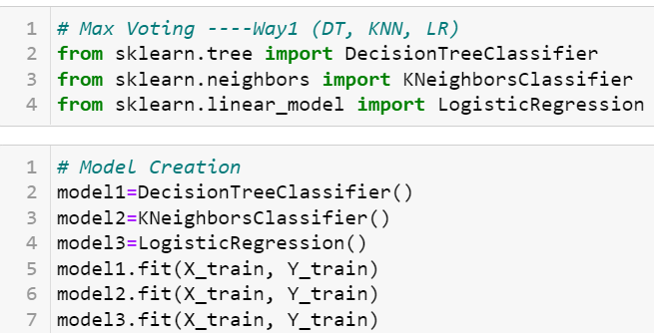

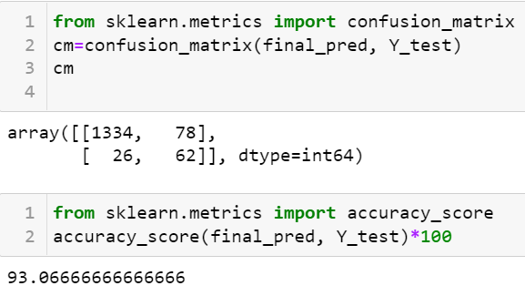
1)B)max voting with 6 algorithms
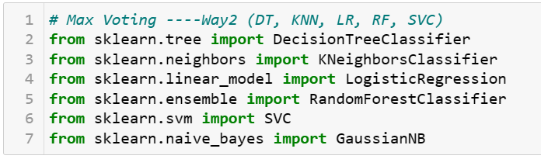

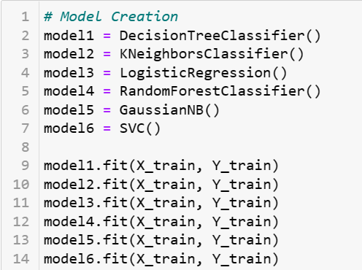

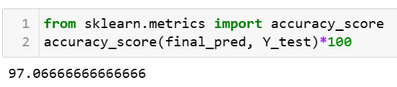

2)A)Averaging with 3 algorithms
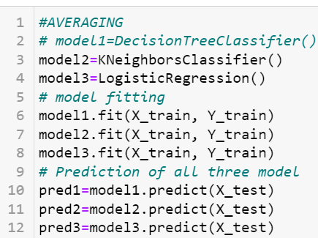

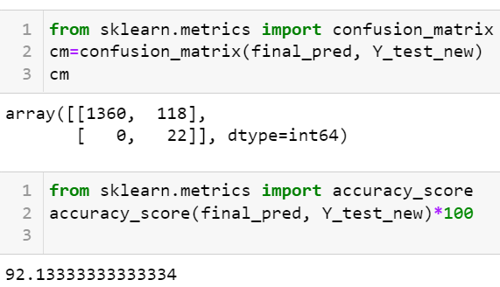
2)B) Averaging with 6 algorithms
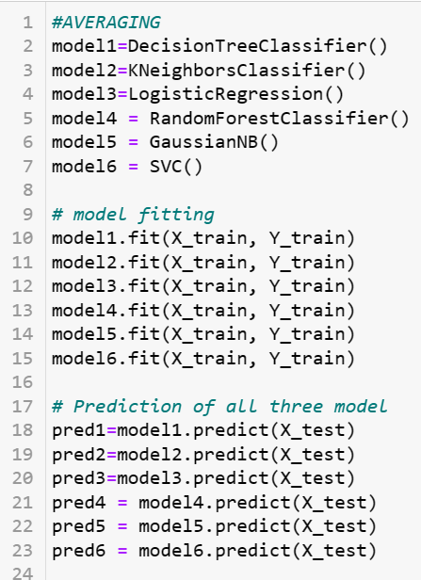
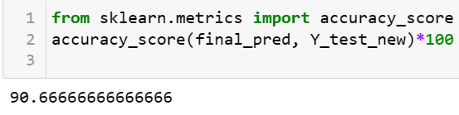
3)A)Weighted average with 3 algorithms
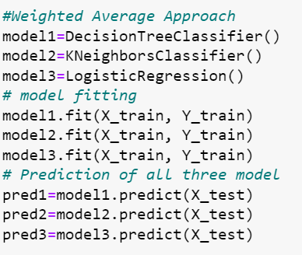
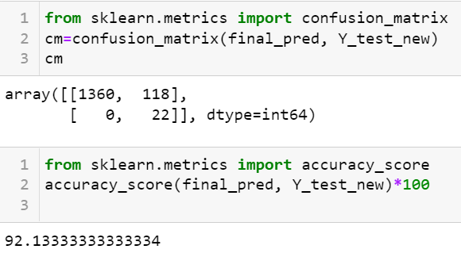
3)B)Weighted average with 6 algorithms
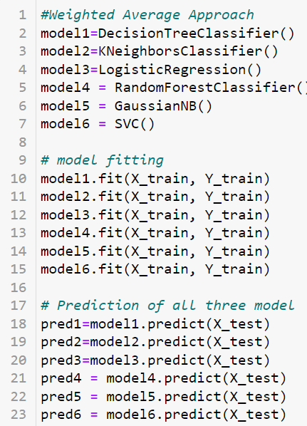
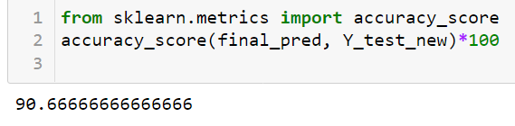

4)A) Stacking with 3 algorithms
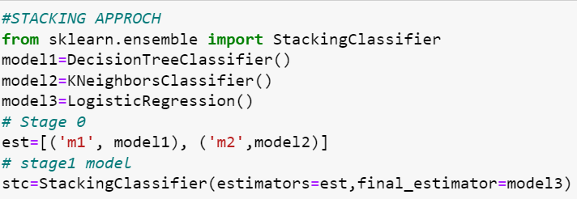
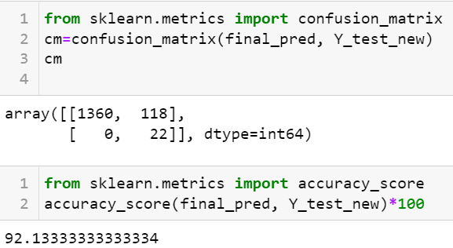
4)B) Stacking with 6 algorithms
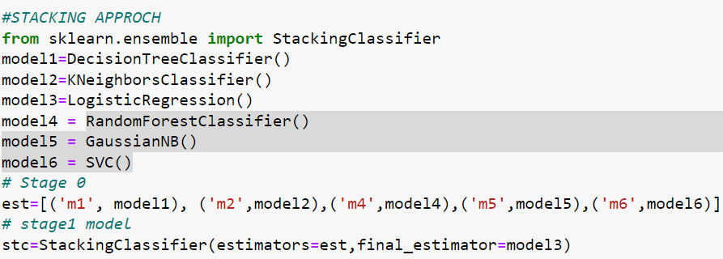
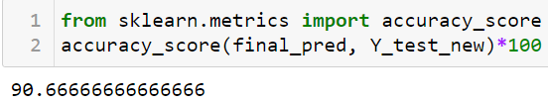
5)Bagging
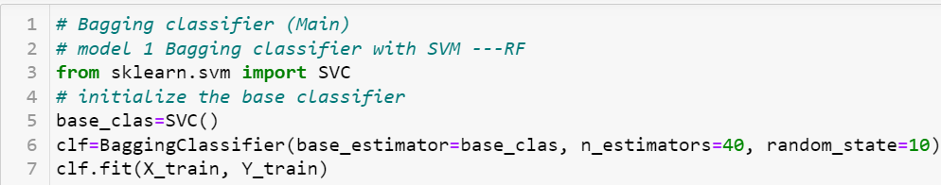

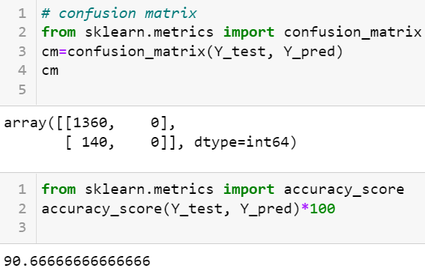
6)Boosting
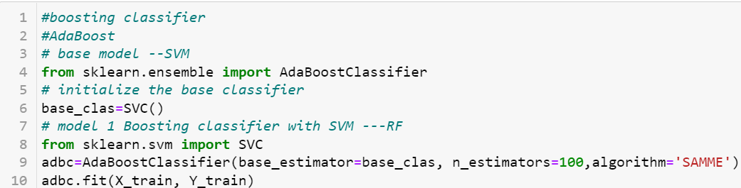
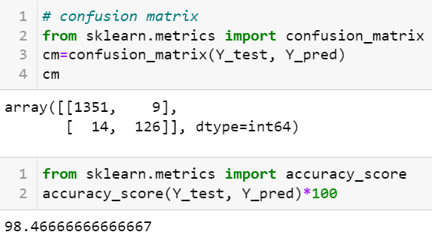
7)Artificial neural network
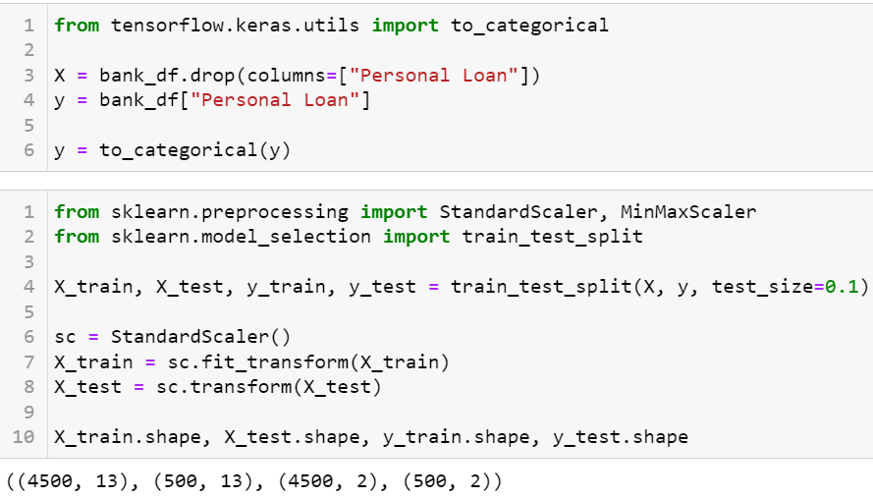
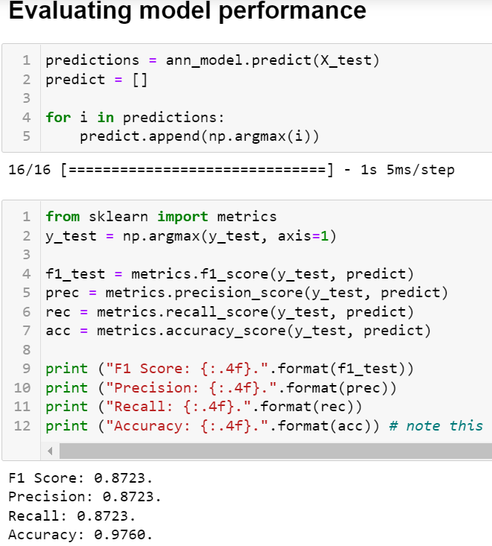
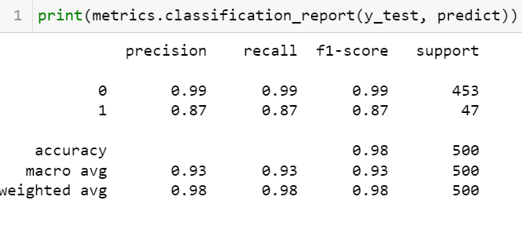

References (Format of references)

- M. A. Sheikh, A. K. Goel and T. Kumar, "An Approach for Prediction of Loan Approval using Machine Learning Algorithm," 2020 International Conference on Electronics and Sustainable Communication Systems (ICESC), 2020, pp. 490-494, doi: 10.1109/ICESC48915.2020.9155614.
- IOSR Journal of Computer Engineering (IOSR-JCE) e-ISSN: 2278-0661,p-ISSN: 2278-8727, Volume 18, Issue 3, Ver. I (May-Jun. 2016), PP 79-81 www.iosrjournals.org
- 021 International Conference on Intelligent Technologies (CONIT) | 978-1-7281-8583-5/21/$31.00 ©2021 IEEE | DOI: 10.1109/CONIT51480.2021.9498475
- M. Alaradi and S. Hilal, "Tree-Based Methods for Loan Approval," 2020 International Conference on Data Analytics for Business and Industry: Way Towards a Sustainable Economy (ICDABI), 2020, pp. 1-6, doi: 10.1109/ICDABI51230.2020.9325614.
- Sai Aparna Vangaveeti1 , Naga Likitha Venna2 , Prasanna Naga Sri RamyaYajamanam Kidambi3 , Harika Marneni4 , Naga Satish Kumar Maganti5 . March 2019 LOGISTIC REGRESSION BASED LOAN APPROVAL PREDICTION
- Advances and Applications in Mathematical Sciences Volume 20, Issue 3, January 2021, Pages- 19 LOAN APPROVAL PREDICTION MODEL A COMPARATIVE ANALYSIS AFRAH KHAN, EAKANSH BHADOLA, ABHISHEK KUMAR and NIDHI SINGH
- Vol 11, Issue 4 , April/2020 ISSN NO:0377-9254 ACCURATE LOAN APPROVAL PREDICTION BASED ON MACHINE LEARNING APPROACH J. Tejaswini1 ,T. Mohana Kavya2 , R. Devi Naga Ramya3 , P. Sai Triveni4 Venkata Rao Maddumala5 1,2,3,4IV B.Tech, Department of Information Technology, Vignan’s Nirula Institute of Technology & Science for Women, Peda Palakaluru, Guntur-522009, Andhra Pradesh, India. 5Asst.Professor, Department of Information Technology, Vignan’s Nirula Institute of Technology & Science for Women, Peda Palakaluru, Guntur-522009, Andhra Pradesh, India. venkatmaddumala@gmail.com
- V. Singh, A. Yadav, R. Awasthi and G. N. Partheeban, "Prediction of Modernized Loan Approval System Based on Machine Learning Approach," 2021 International Conference on Intelligent Technologies (CONIT), 2021, pp. 1-4, doi: 10.1109/CONIT51480.2021.9498475.

